Step 1 - Log in to http://<ip_adress>:7189

Step 2 - Accept license agreement

Step 3 - log in with admin/admin

Step 4 - See this screen:

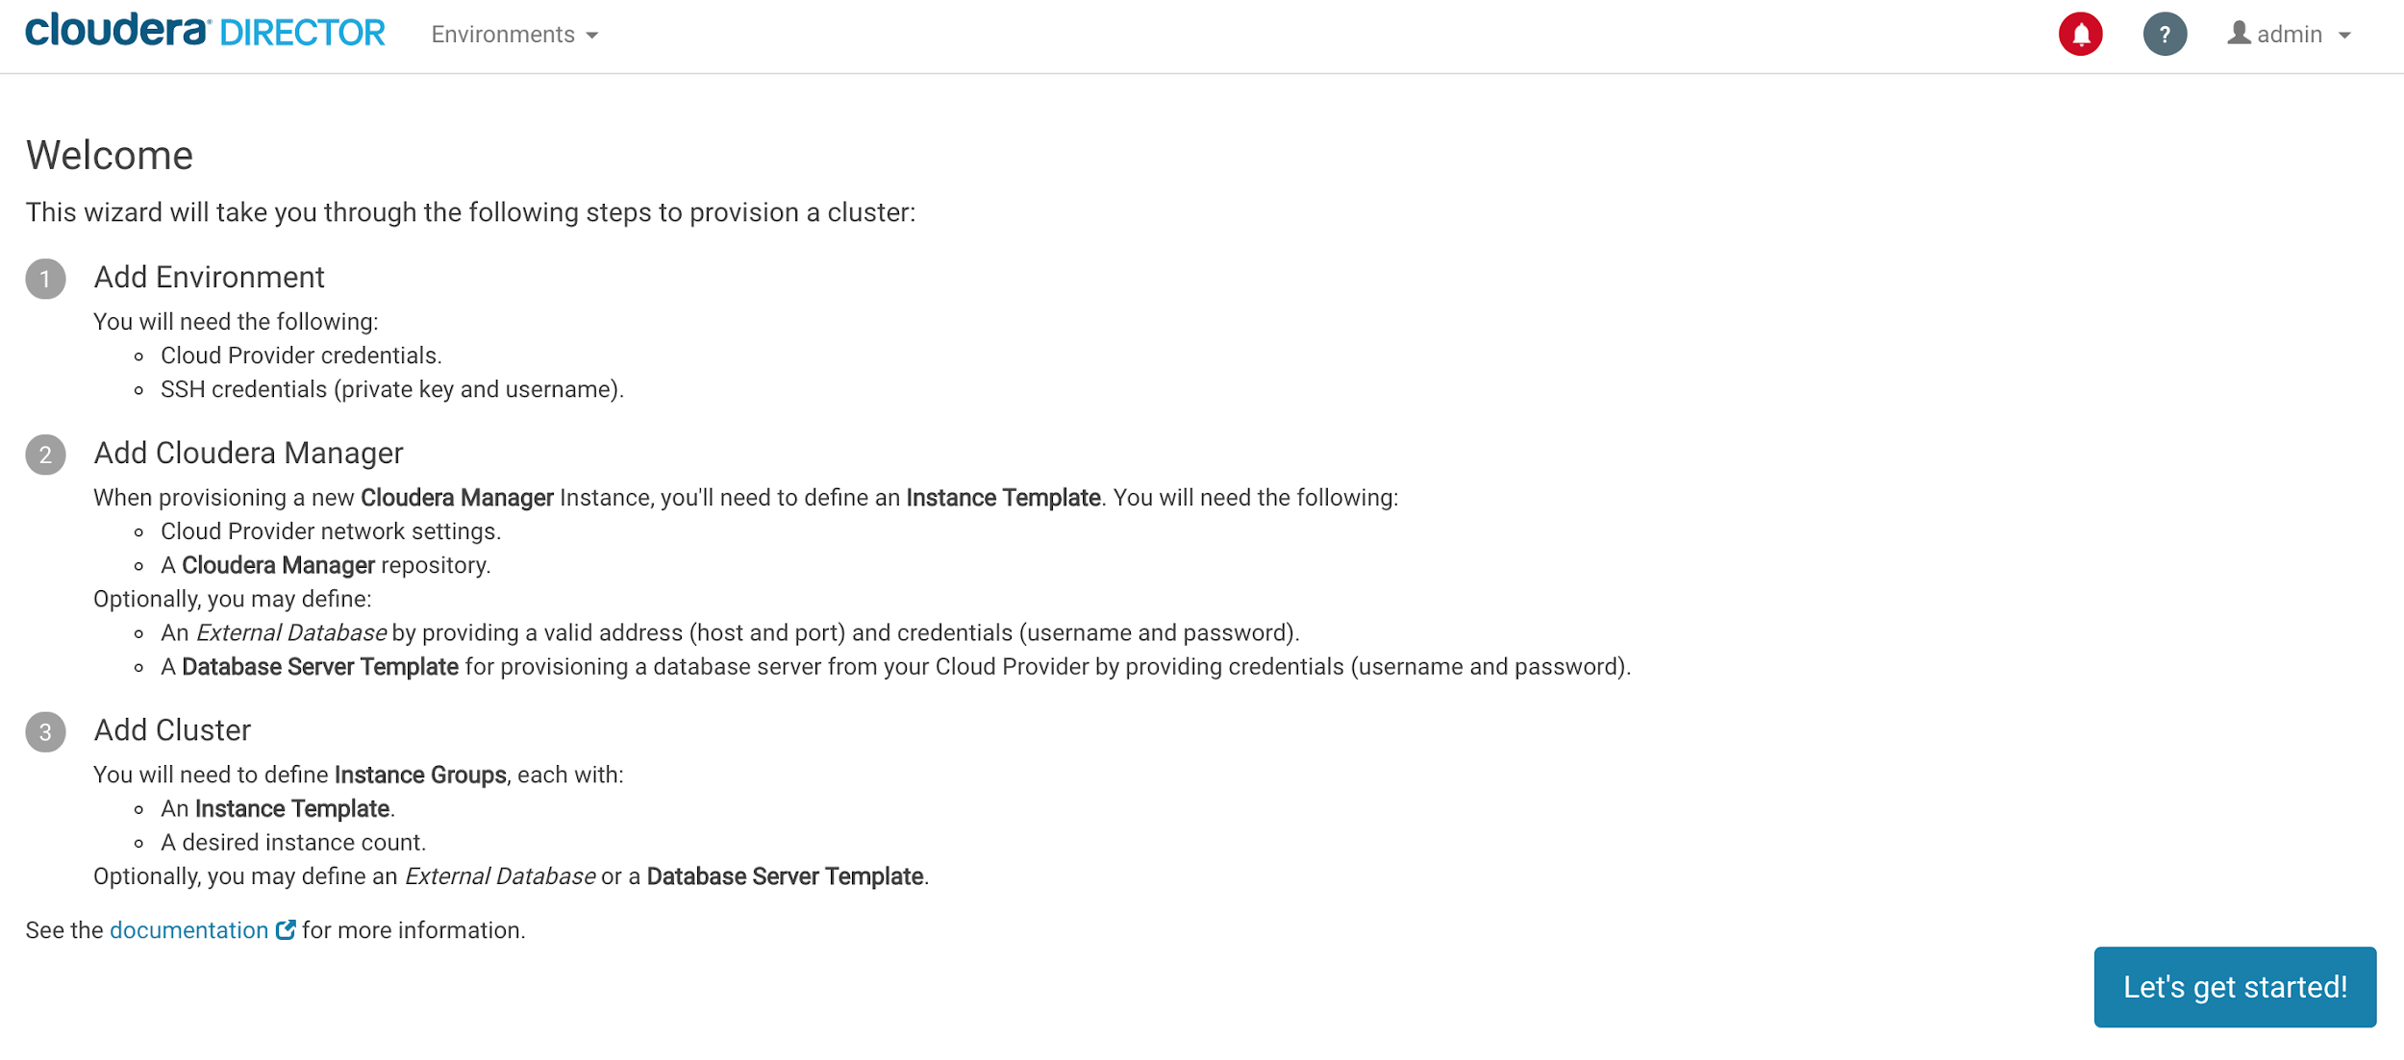

Step 5 - Go to “Let’s get started” and add environment details:

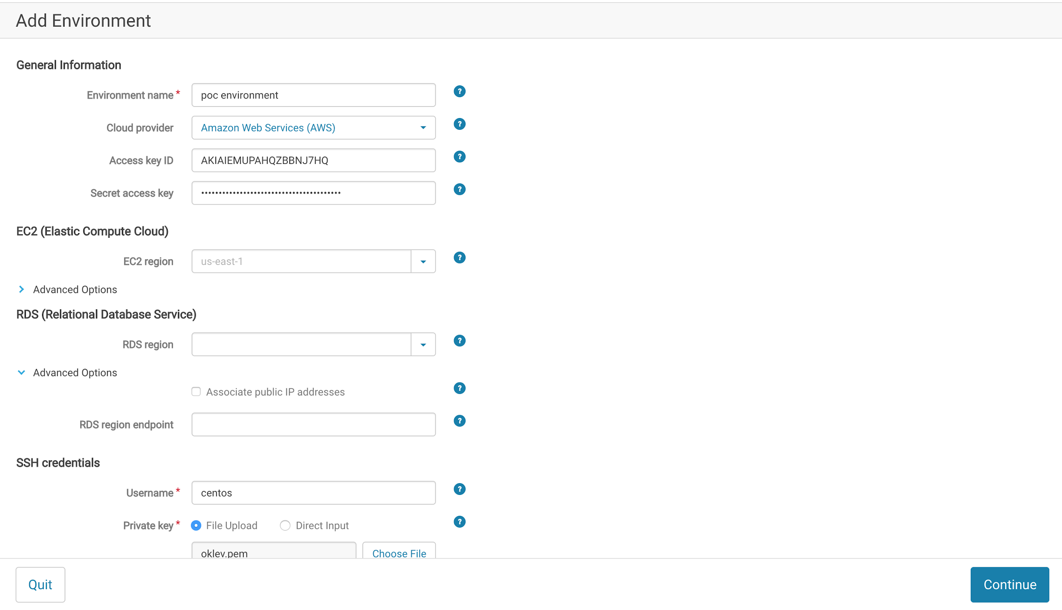

Step 6 - Press “Continue” and add details for future Cloudera Manager

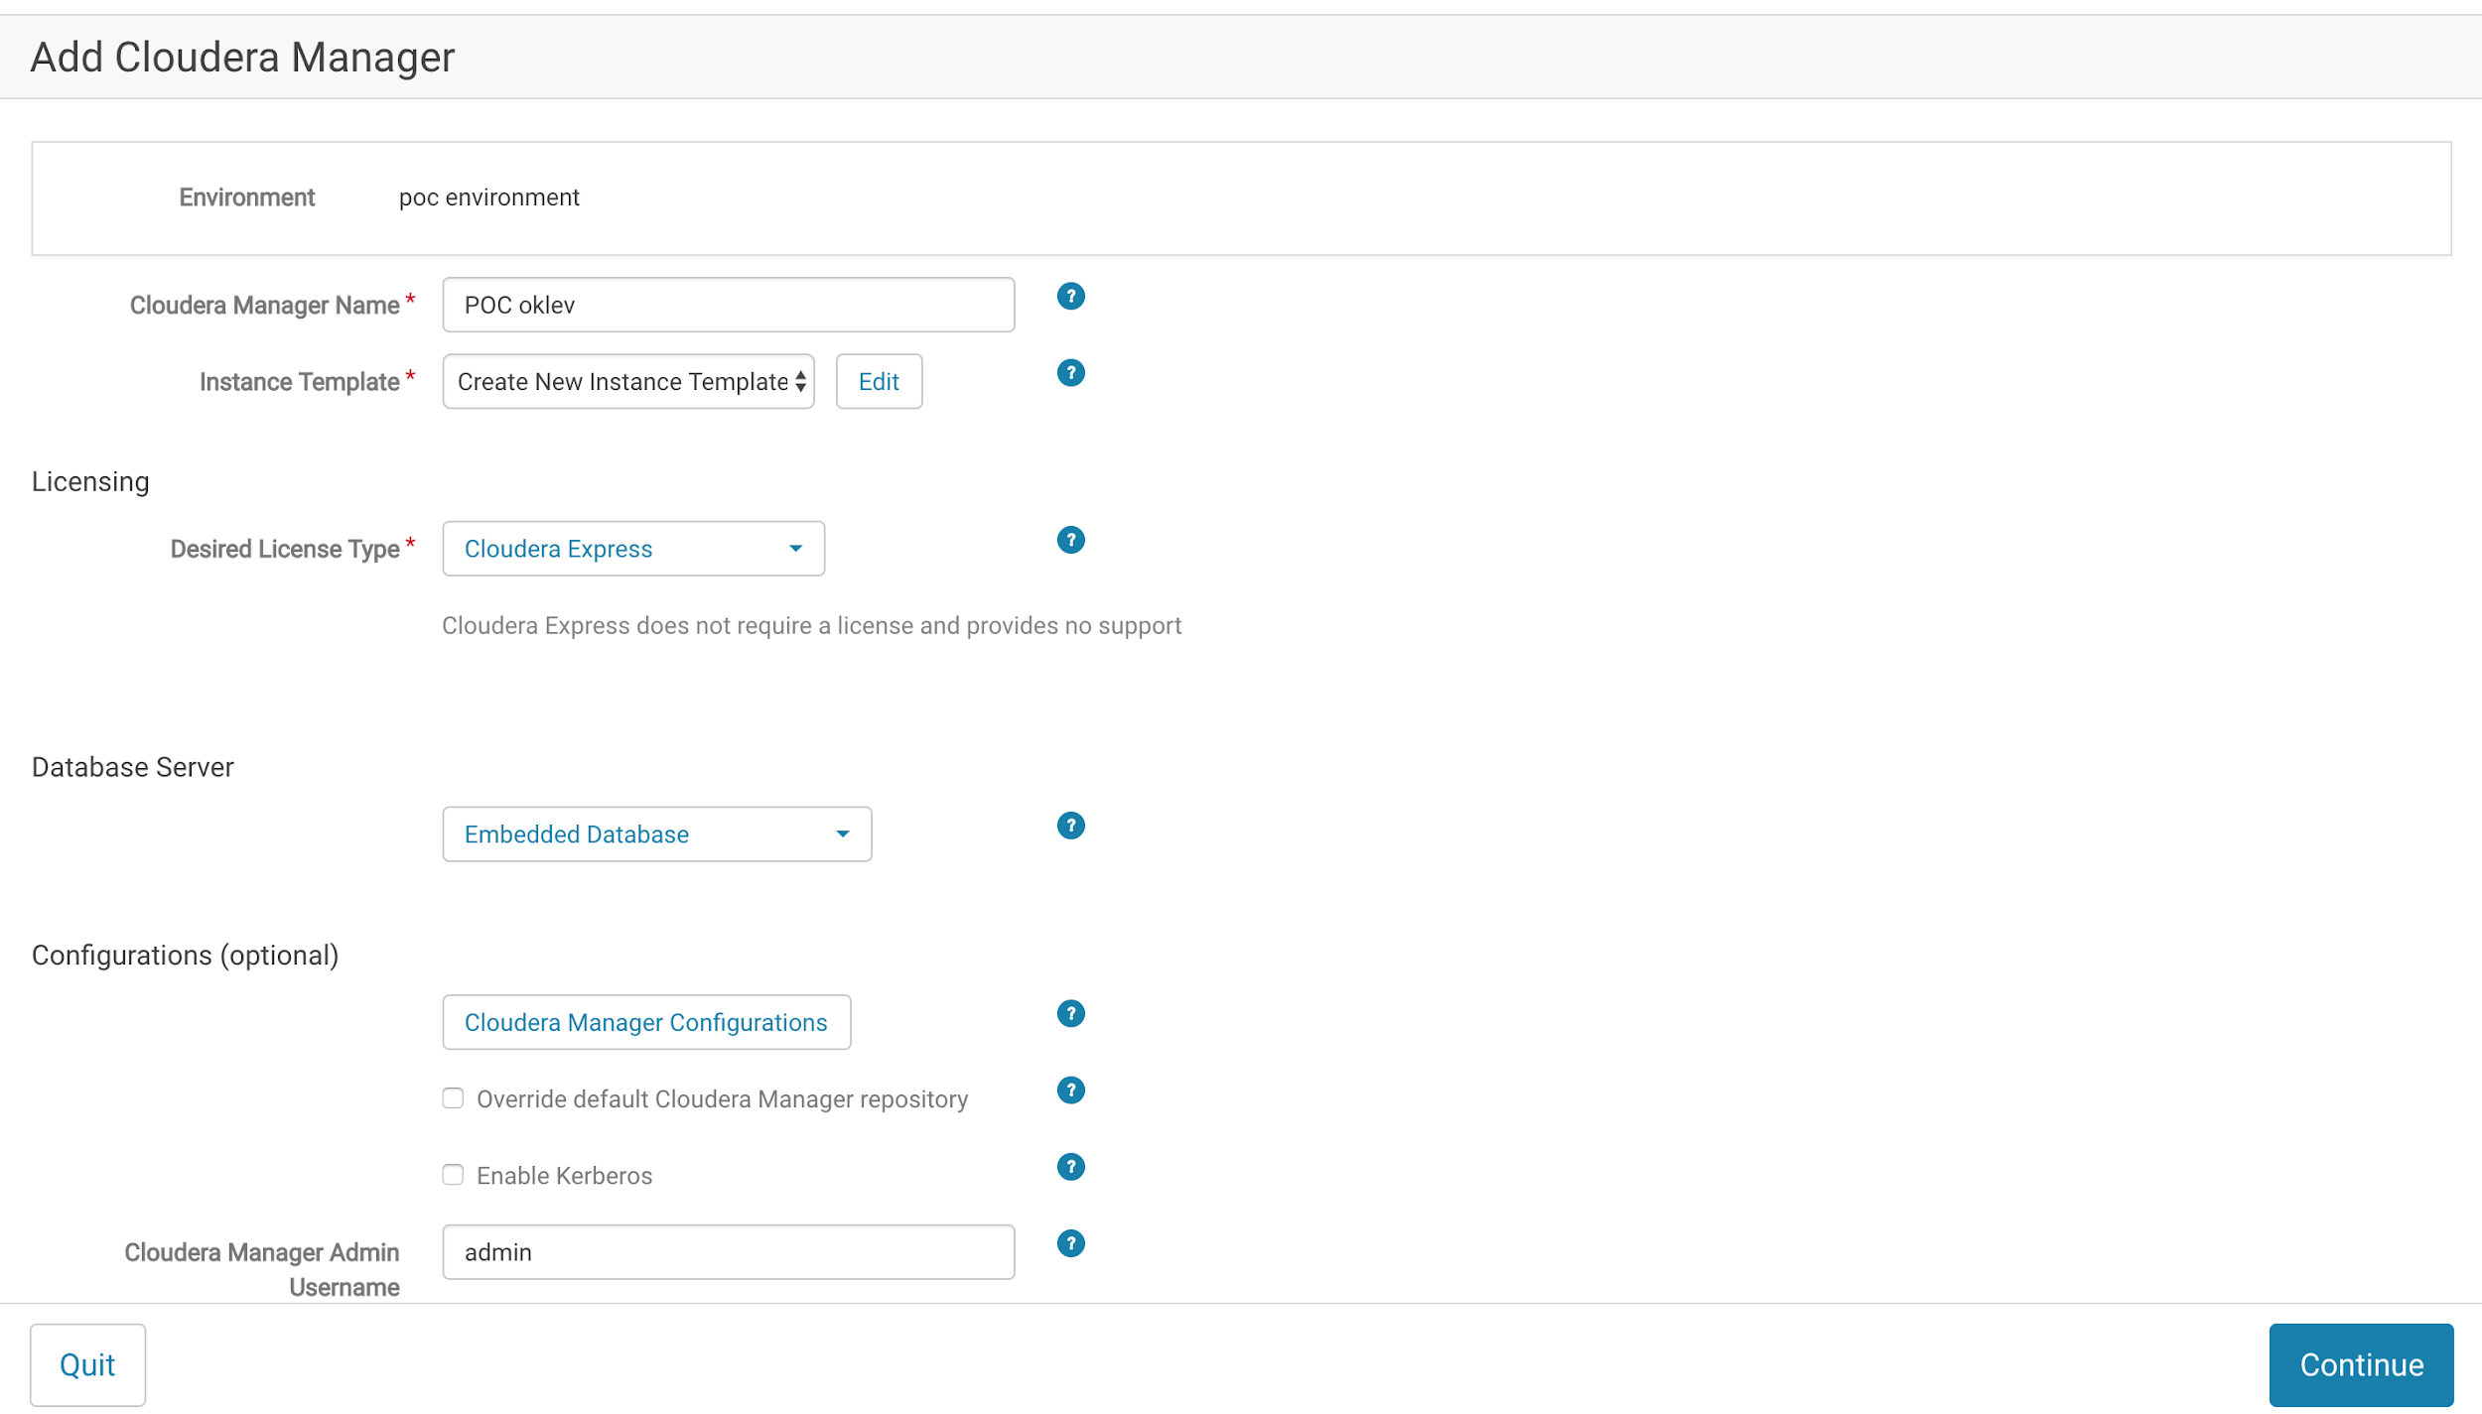

Step 7 - Edit new instance template

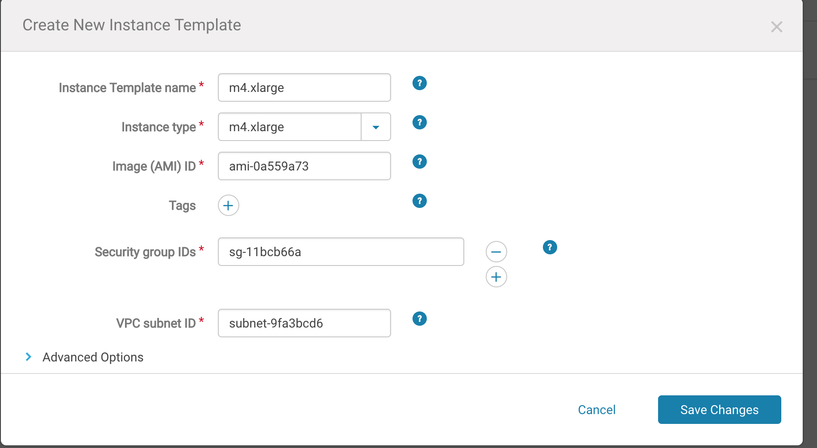

Step 8 - Save changes and press “Continue” and OK

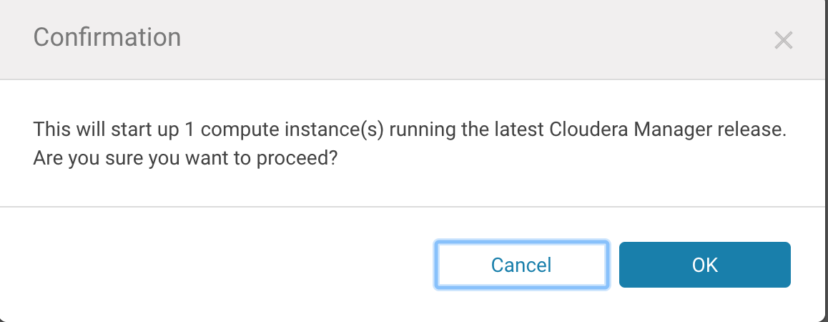

Step 9 - You should see the page with a progress bar

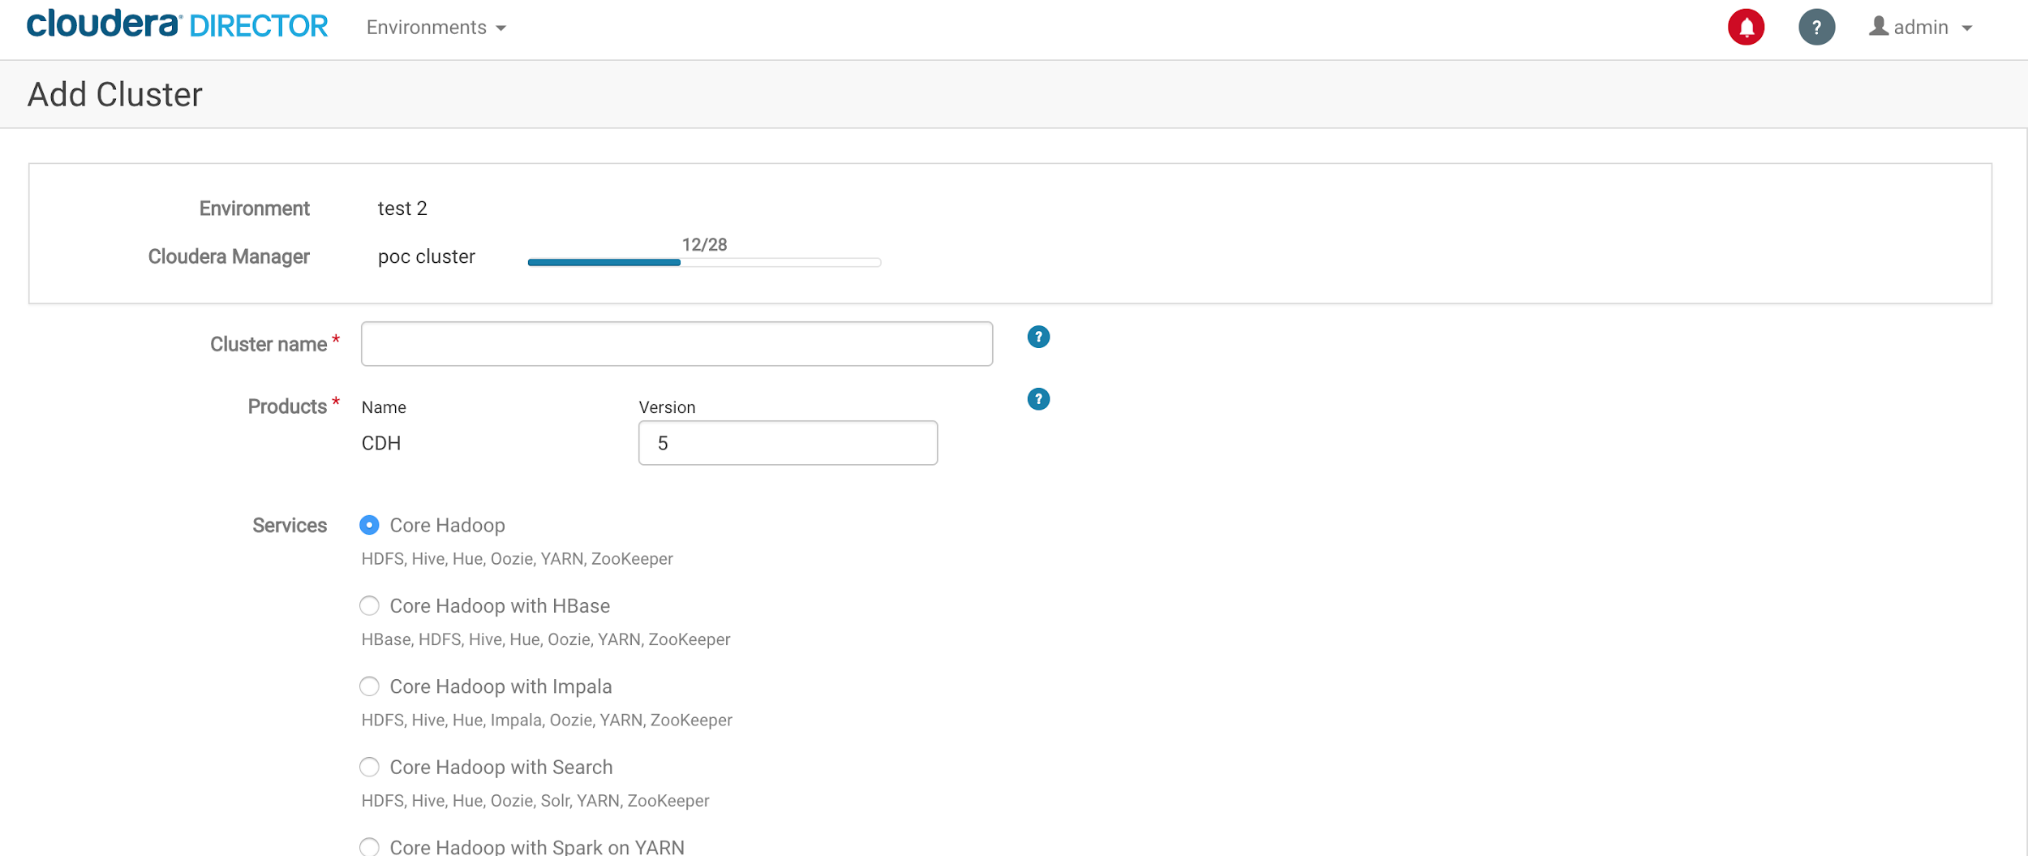

Step 10 - Once CM is installed, we can setup our CDH cluster

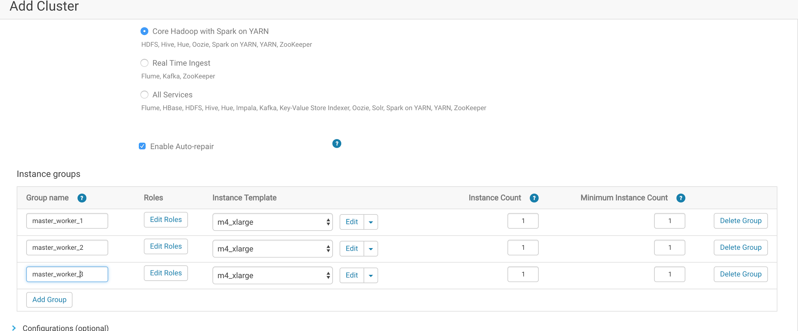

Master+worker1 group:

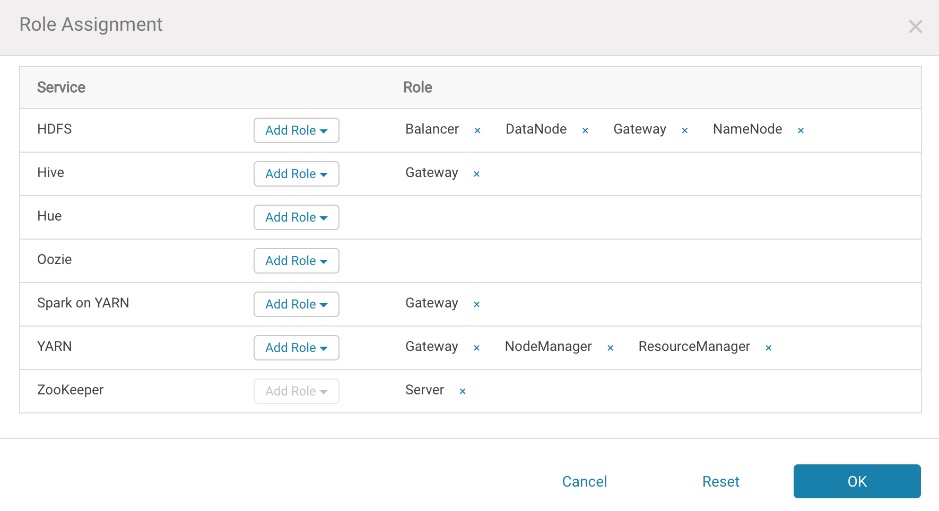

Master+worker2 group:

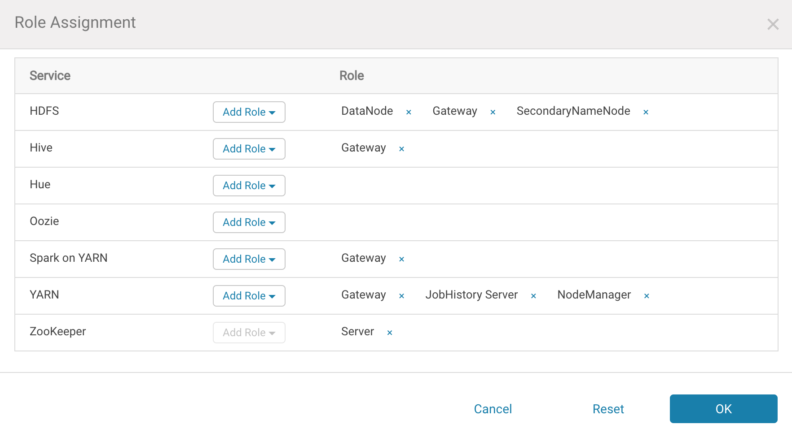

Master+worker3 grouop:

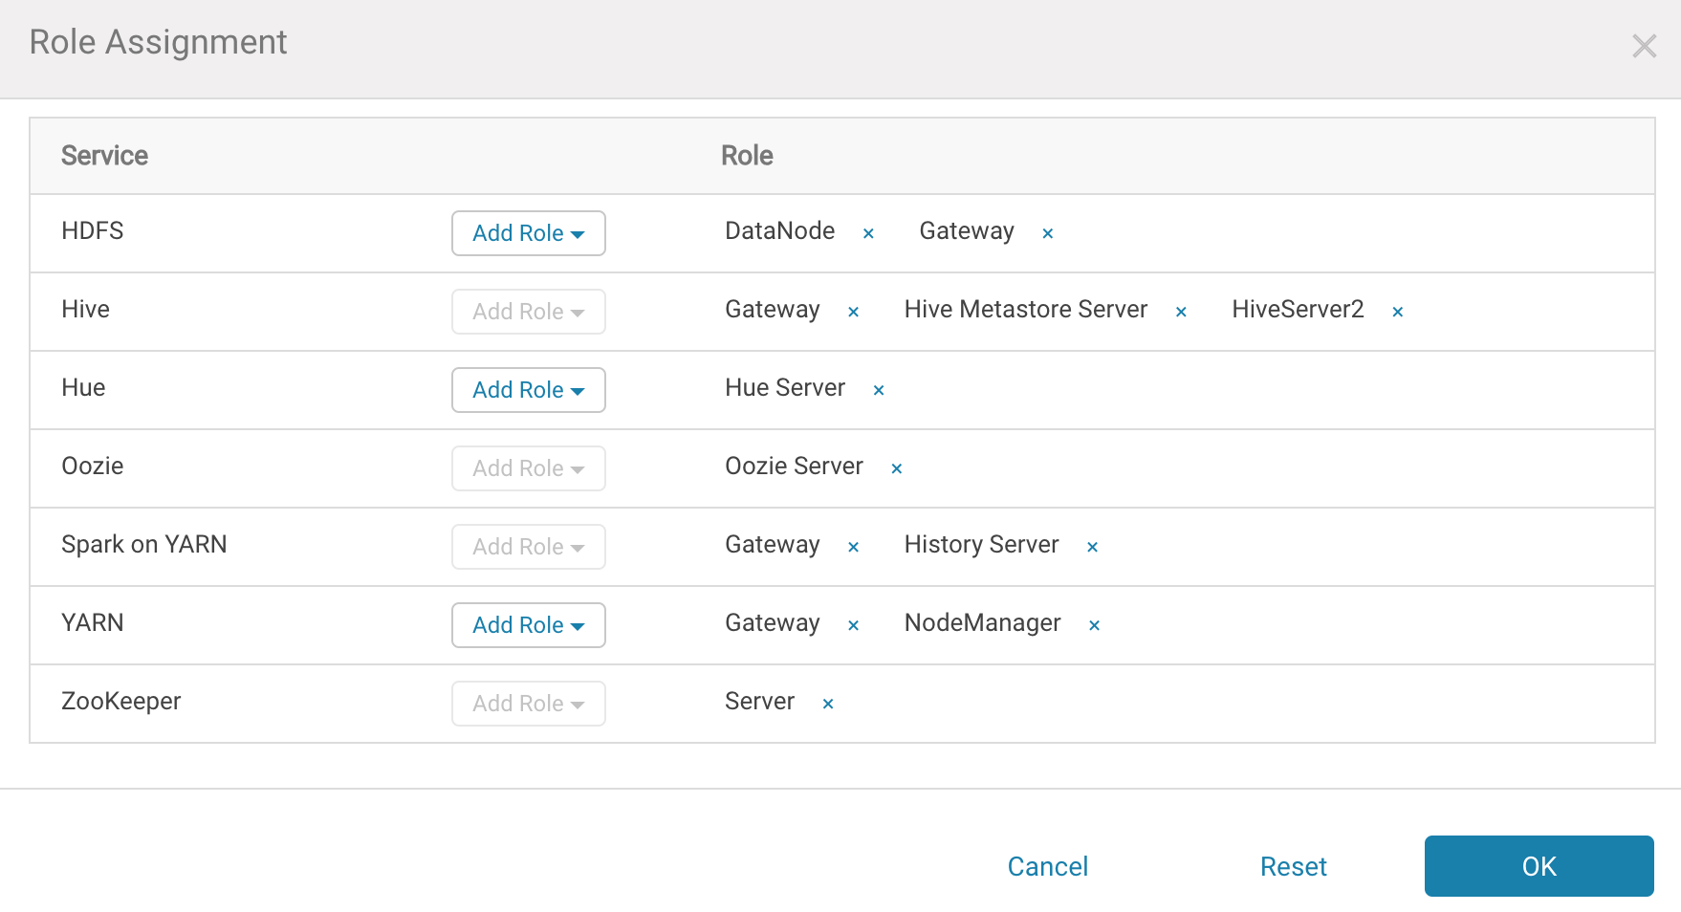

Press OK for this confirmation:

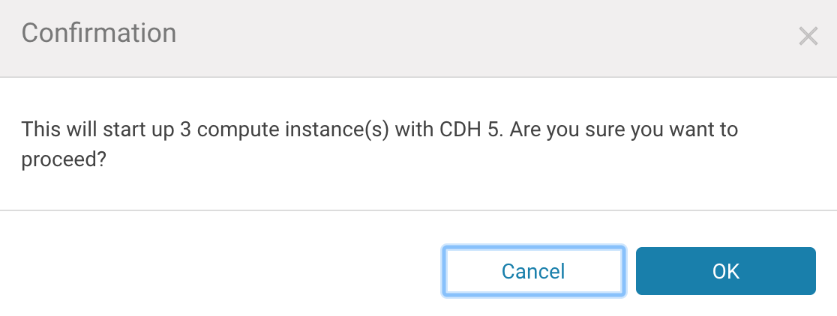

You should see something like this:

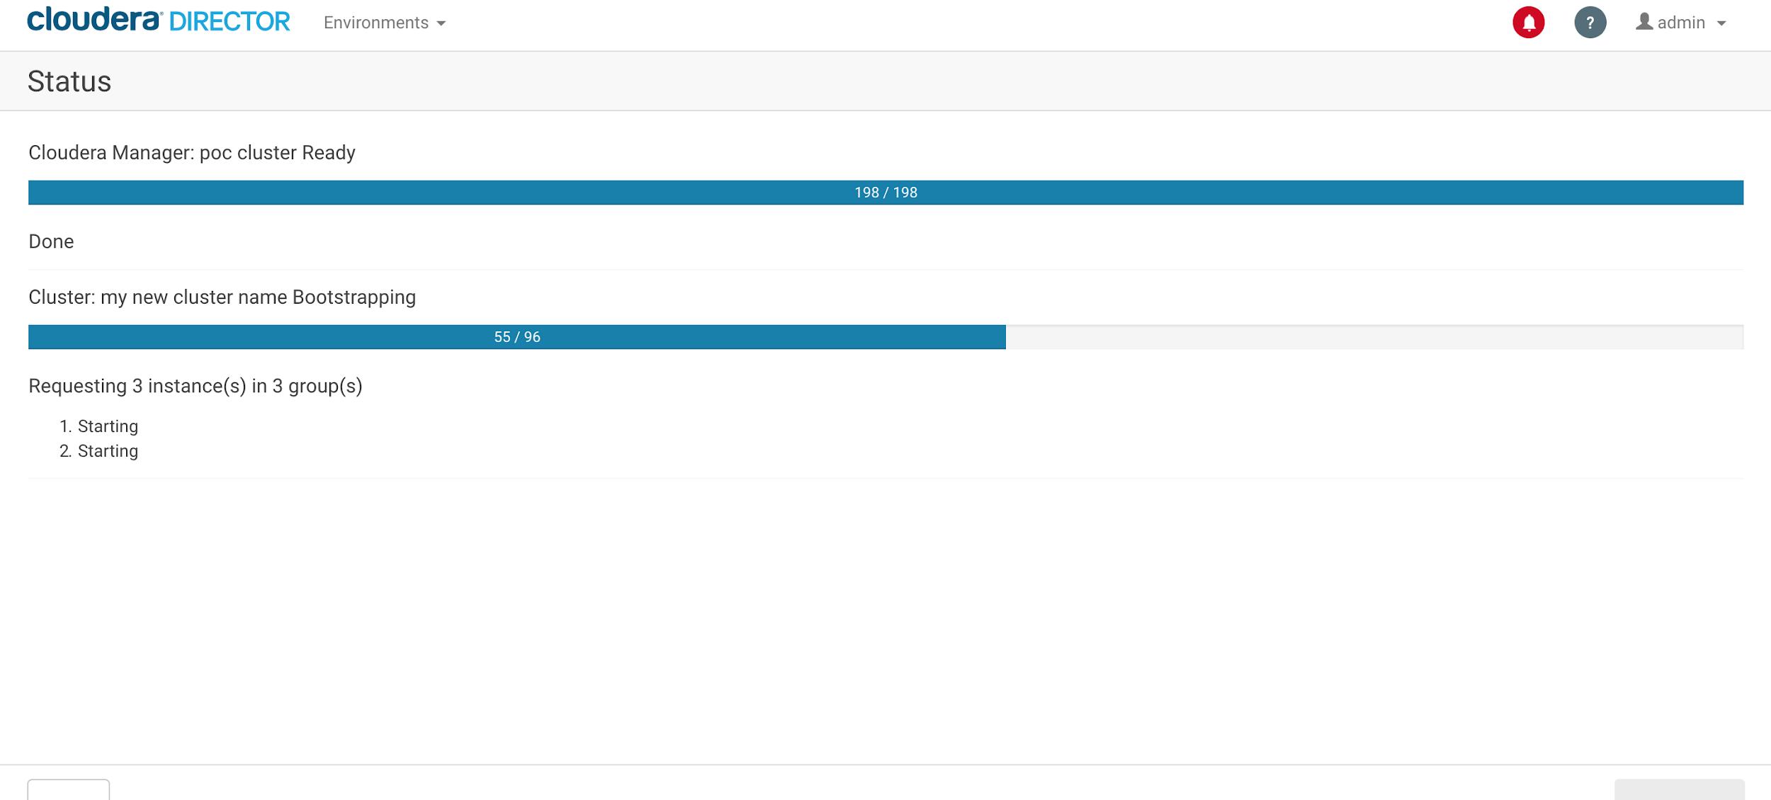

Once cluster setup is done, you should see something like this:

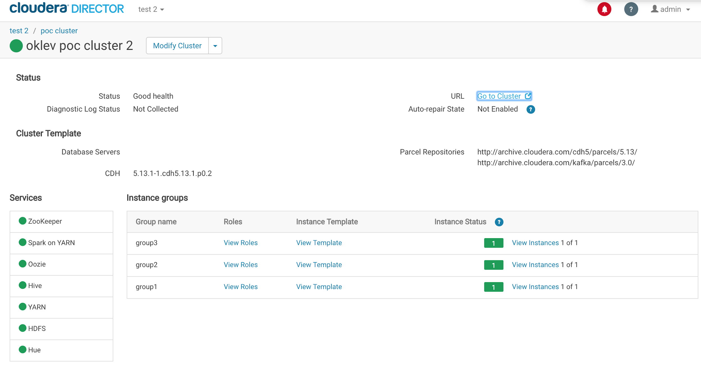

Press “Go to Cluster”, so that you will be forwarded to Cloudera Manager:

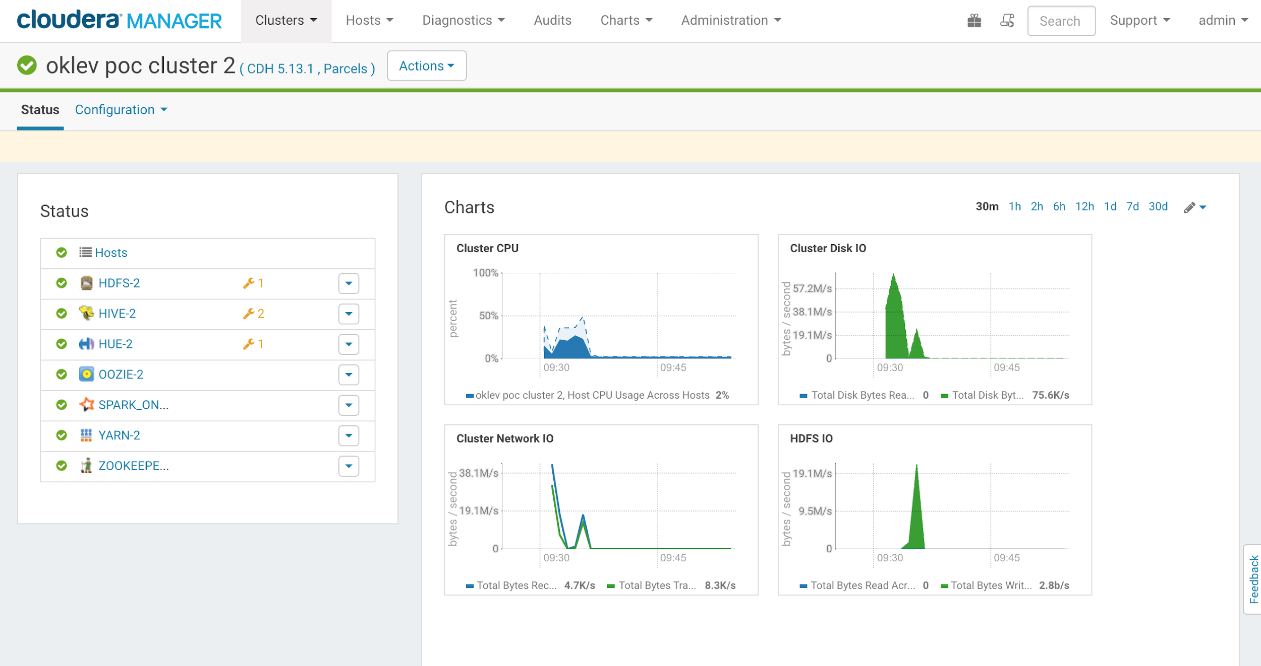

You cluster is ready!!!!!!!